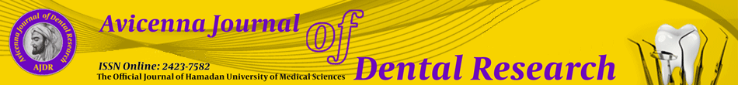
Exclusive License Agreement

The Hamadan University of Medical Sciences (UMSHA) Press will be pleased to publish your article entitled
-------------------------------------------------------------------------------------------------------------------

-------------------------------------------------------------------------------------------------------------------

All of the authors, including myself, have reached an agreement that if our article is accepted for publication, it will be subject to the Creative Commons Attribution License 4.0. However, this agreement will be null and void if the Work is not published in the Journal.
The undersigned author(s) warrant that the Work is original, does not infringe on any copyright or other proprietary right of any third party, is not under consideration by another journal, and has not been previously published.
(This agreement must be signed by all authors listed in the Work. A photocopy of this form may be used if there are more than 5 authors.)

Author’s name & signature Date

Author’s name & signature Date

Author’s name & signature Date

Author’s name & signature Date

Author’s name & signature Date

